KENTRACK 4.0: A RAILWAY TRACKBED STRUCTURAL DESIGN PROGRAM
Shushu Liu, Jerry G. Rose, Reginald R. Souleyrette
Department of Civil Engineering, University of Kentucky, Lexington, KY
The KENTRACK program is a finite element based railway trackbed structural design program that can analyze trackbeds having various combinations of all-granular and asphalt-bound layered support. It is applicable for calculating compressive stresses at the top of subgrade and tensile strains at the bottom of the asphalt layer for trackbeds containing an asphalt layer. The program was recently expanded to include both English and international units. More importantly, properties of performance graded (PG) asphalt binders and the Witczak E* predictive model were incorporated in the 4.0 Version of the program. Component layers of typical trackbed support systems were analyzed while evaluating the significance of layer thicknesses and material properties on design and predicted performance. Variances in subgrade modulus and the incorporation of a layer of asphalt within the track structure have significant effects on subgrade vertical compressive stresses and predicted trackbed service lives.

Introduction
In the previous KENTRACK versions, asphalt dynamic modulus was predicted using the method developed by the Asphalt Institute (1). A shortcoming of the model is that viscosity is sensitive to temperature. Using a constant value for viscosity at 135 ° F leads to an underestimate asphalt dynamic moduli. Further, since Superpave improved the performance of asphalt and PG System for asphalt binders (2), the old asphalt dynamic modulus predictive model existing in KENTRACK 3.0 (1) is not sufficiently accurate to predict dynamic modulus of PG asphalt binders. Therefore, updating the predictive model was desirable to include asphalt dynamic modulus, so that both the Asphalt Cement system based asphalt binders that were used in old trackbeds, and PG system based asphalt binders that are used in newly constructed trackbeds can be evaluated.

KENTRACK Theory
Three types of trackbeds, as depicted in Figure 1, are included in KENTRACK – All-Granular trackbed, Asphalt Underlayment trackbed, and Combination trackbed.
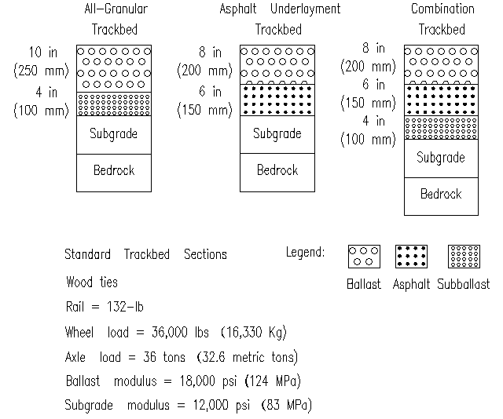
Figure 1. Standard Default Trackbed Sections
The program is based on the Asphalt Institute's DAMA program using highway failure criteria and layer elastic design. Subballast and subgrade are considered as linear elastic. The bedrock is assumed incompressible. Ballast in a newly constructed trackbed behaves non-linearly while in an aged trackbed it behaves linearly (3). Asphalt is considered to be viscoelastic. The Witczak E* predictive model is incorporated into KENTRACK 4.0 to calculate asphalt dynamic modulus (2).
Tensile strain calculations at the bottom of asphalt and compressive stress calculations at the top of subgrade are performed as damage analysis in KENTRACK. Material properties may vary seasonally due to temperature changes which result in a different result of damage analysis in a different season.
The passage of one car in a train is considered equivalent to one load repetition. The center portion of the car represents the “unloaded” phase. The predicted number of repetitions varies with the traffic that the trackbed is subjected.

Case Study

a. Subgrade Compressive Stress b. Subgrade Service Life

c. Asphalt Tensile Strain d. Asphalt Service Life
Figure 2. Effects of Varying Subgrade Modulus (Axle Load = 36 tons)

Figure 2(a)-(d) show the effect of varying subgrade modulus on different types of trackbeds. More discussions can be found in the reference (3). The increase in subgrade modulus leads to higher bearing capacity, the increment of the bearing capacity of the subgrade is always greater than the increment of the subgrade compressive stress, therefore as subgrade modulus increases, subgrade compressive stresses also slightly increase, together with a significant increase in predicted subgrade service life.
The tensile strain decreases as subgrade modulus increases. For low subgrade moduli, the subgrade cannot adequately support the loadings on the asphalt layer. In this case, with the same load on the asphalt layer, deformation of the asphalt increases on the soft subgrade, producing higher tensile strains on the bottom of the asphalt layer due to excessive bending strains.
Also, the predicted subgrade service life for an asphalt trackbed is typically increased by 100% over that of an all-granular trackbed. A combination trackbed has longer predicted service lives of the subgrade and asphalt layers than asphalt underlayment trackbed.

Closure
The KENTRACK program is a finite element based railroad trackbed design program. The Witczak E* predictive model for asphalt was applied in Version 4.0. Asphalt binders, classified in either AC system or PG system, can be used in KENTRACK 4.0. The program was expanded to include the SI international unit system. The program is applicable for determining relative effects of varying parameters and effects on design considerations.
For a given type of trackbed, the effect of subgrade stiffness is the most significant factor influencing the design. For a given loading configuration, stiffer subgrades produce slightly higher subgrade stresses, but the predicted service lives for the stiffer subgrades are increased significantly. Asphalt tensile stresses are lower for the stiffer subgrades and the predicted service lives are increased proportionally.
An asphalt trackbed results in lower subgrade stress than a similar thickness of all-granular trackbed. This is is more pronounced when subballast is added to the asphalt trackbed forming a combination trackbed. For a given level of subgrade stiffness and axle loading, predicted subgrade design lives are higher for both the asphalt and combination trackbeds as compared to an all-granular design.

References
- Rose, J.; Agarwal, N. K.; Brown, J. D. and Ilavala, N. (2010). KENTRACK, A Performance-Based Layered Elastic Railway Trackbed Structural Design and Analysis Procedure – A Tutorial, Proceedings of the 2010 Joint Rail Conference, 38 pages.
- Advanced Research Associates. (2004). 2002 Design Guide: Design of New and Rehabilitated Pavement Structures, NCHRP 1-37A Project, National Cooperative Highway Research Program, National Research Council, Washington, DC.
- Liu, S. (2013) KENTRACK 4.0: A Railway Trackbed Structural Design Program. Theses and Dissertations--Civil Engineering. Paper 16.
http://uknowledge.uky.edu/ce_etds/16

